**Access for Koerber - Creating K1 Users**

**Occurrence of Issue:** The User wants access to Koerber for Self.

**Incident Documentation:**

**Summary**  :  
  
Access for Koerber has been requested for Chaz Shields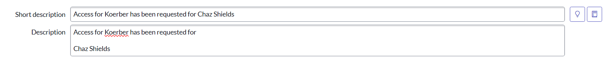  
**Initial Investigation :** Ask about the which all permissions, Warehouse and template is required.

:  
  
1. Login to “Koerber One”:-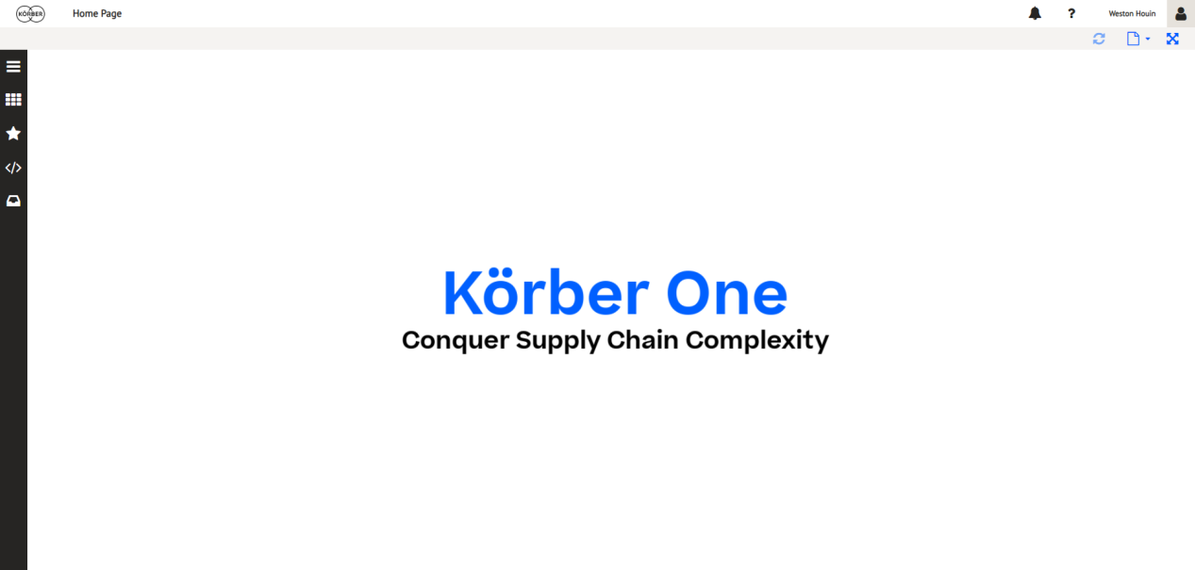  
2. Navigate to the “User and Roles” page under “Koerber One” > “Security” > “User and Roles”.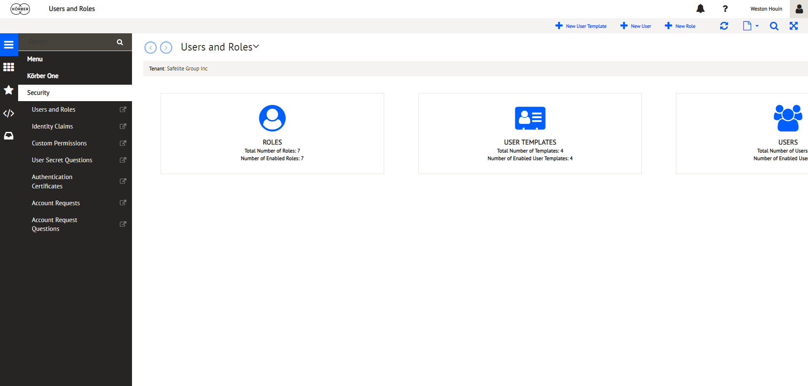

3. Click on the “+ New User” button.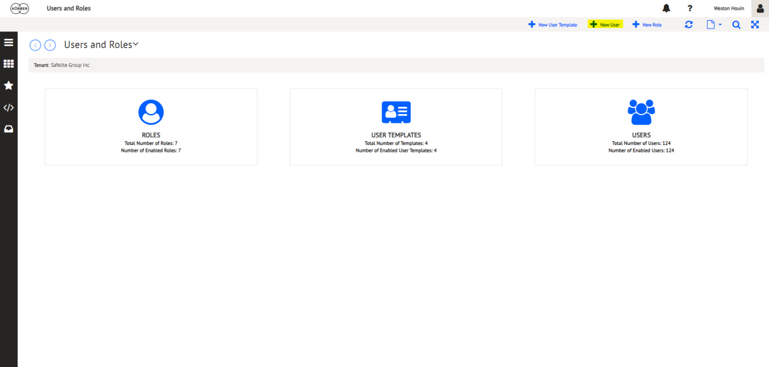  
4. Click on the folder icon to display available user templates.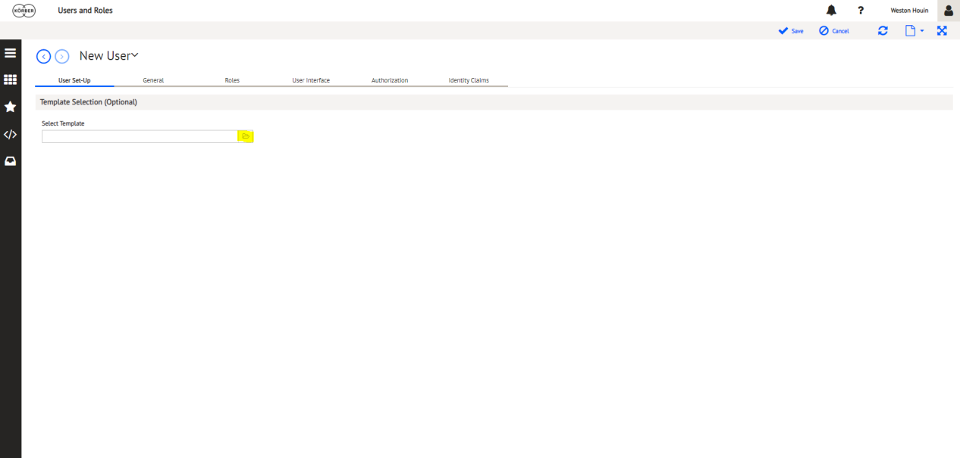  
5. Select the correct user template for the new K1 user. (QA users for test should be given admin permissions for Supply Chain only)

K1 Menu Levels:

Administrator

-Supply Chain Excellence

Production

-Whse Assoc 1

-Whse Assoc 2

-Whse Lead

-DC Associate

-DC Lead

Manager

-Whse Manager

-Whse Supervisor

Inventory

-DC Inv Ctrl Manager

-DC Inv Ctrl Specialist

-DC Supervisor

-DC Shift Manager

-DC Manager

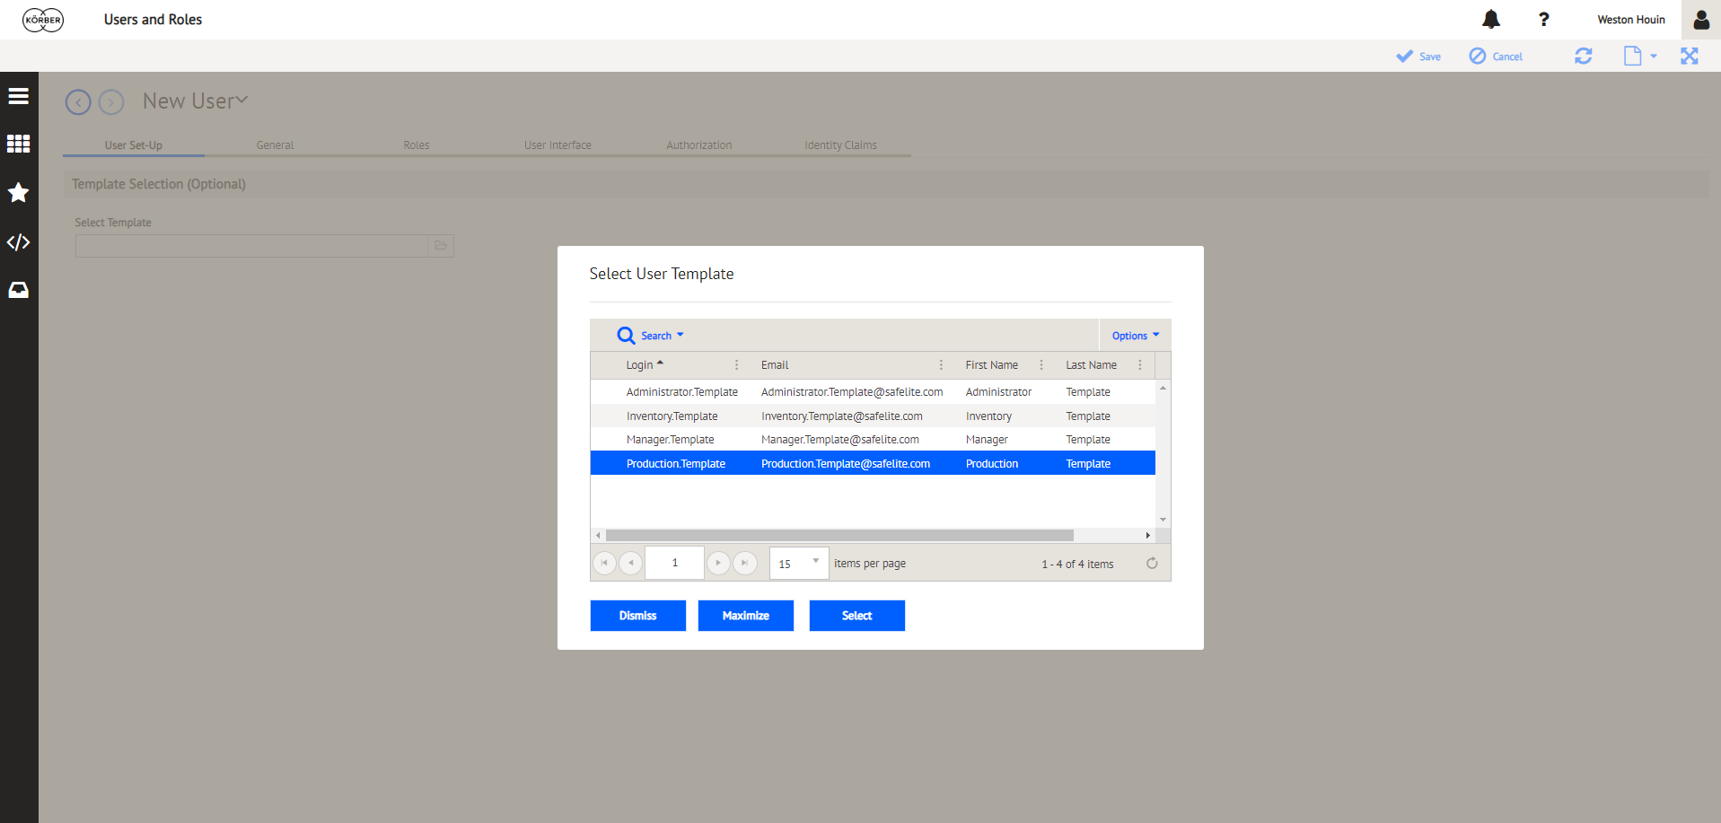6. Fill out the general user information on the “General” tab. Set up the K1 user as SSO only (single sign-on for Okta).

1. User Name must be FirstName.LastName

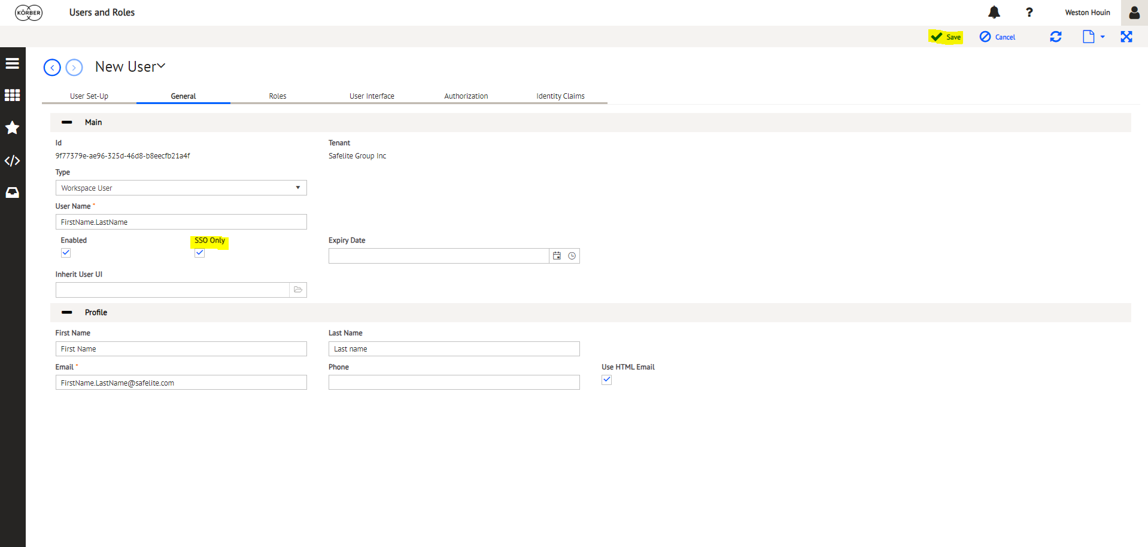

1. Navigate to “Warehouse User Assignment” page under “Koerber One” > “Supply Chain Advantage” > “User Management” > “Warehouse User Assignment” and search for the user you created (K1 Username).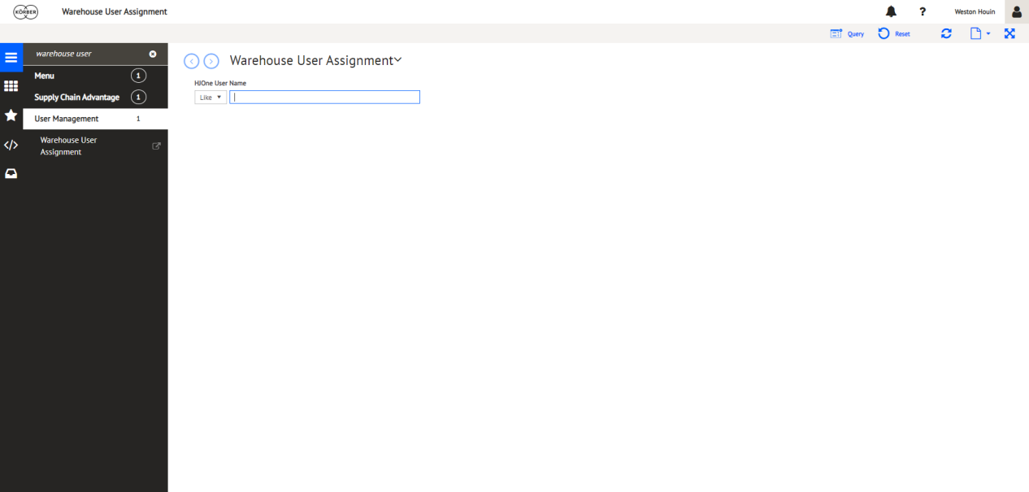  
   8. Click into the “Assigned Count” link for the user.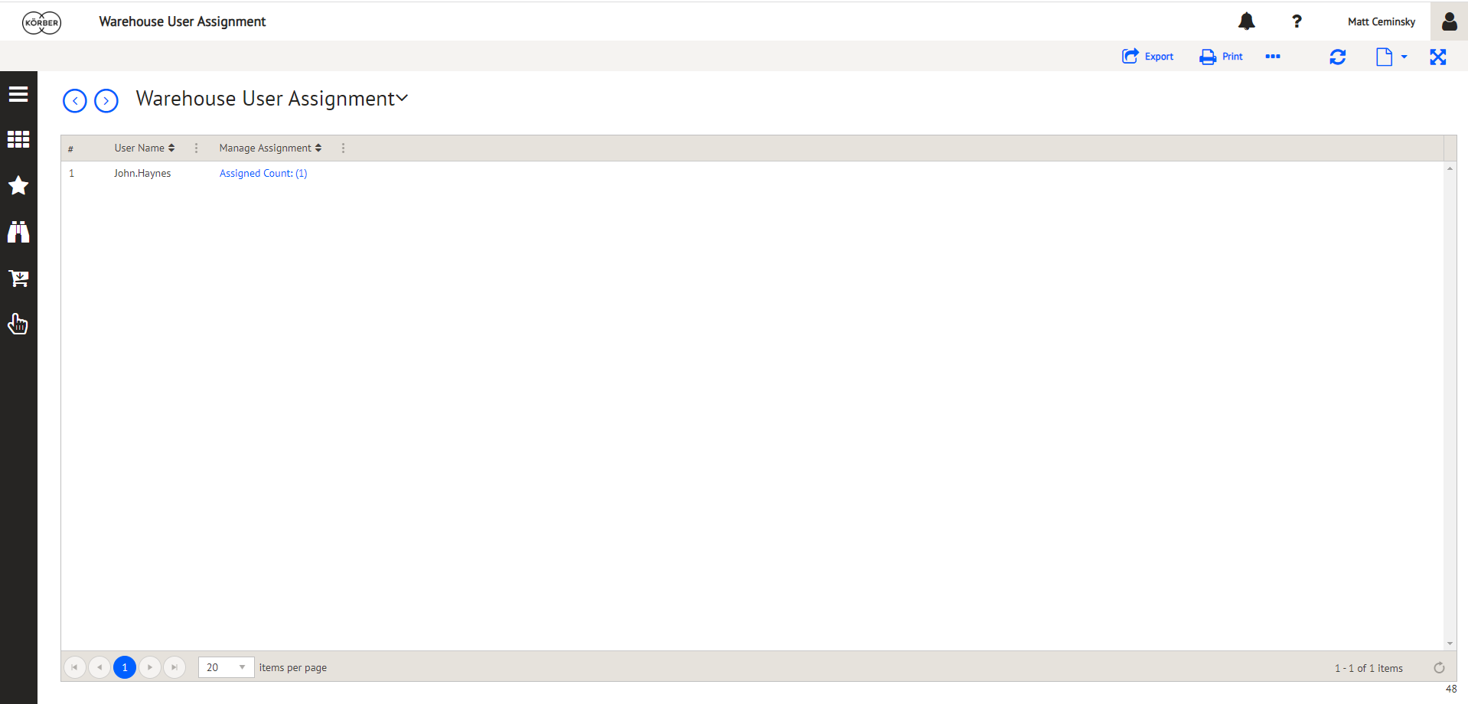  
   9. Filter by warehouse (Whse). Assign the user to the warehouse they need and select it as their default warehouse also (“Allow Any” should be for corporate users only). Click “Apply” and then “Done”.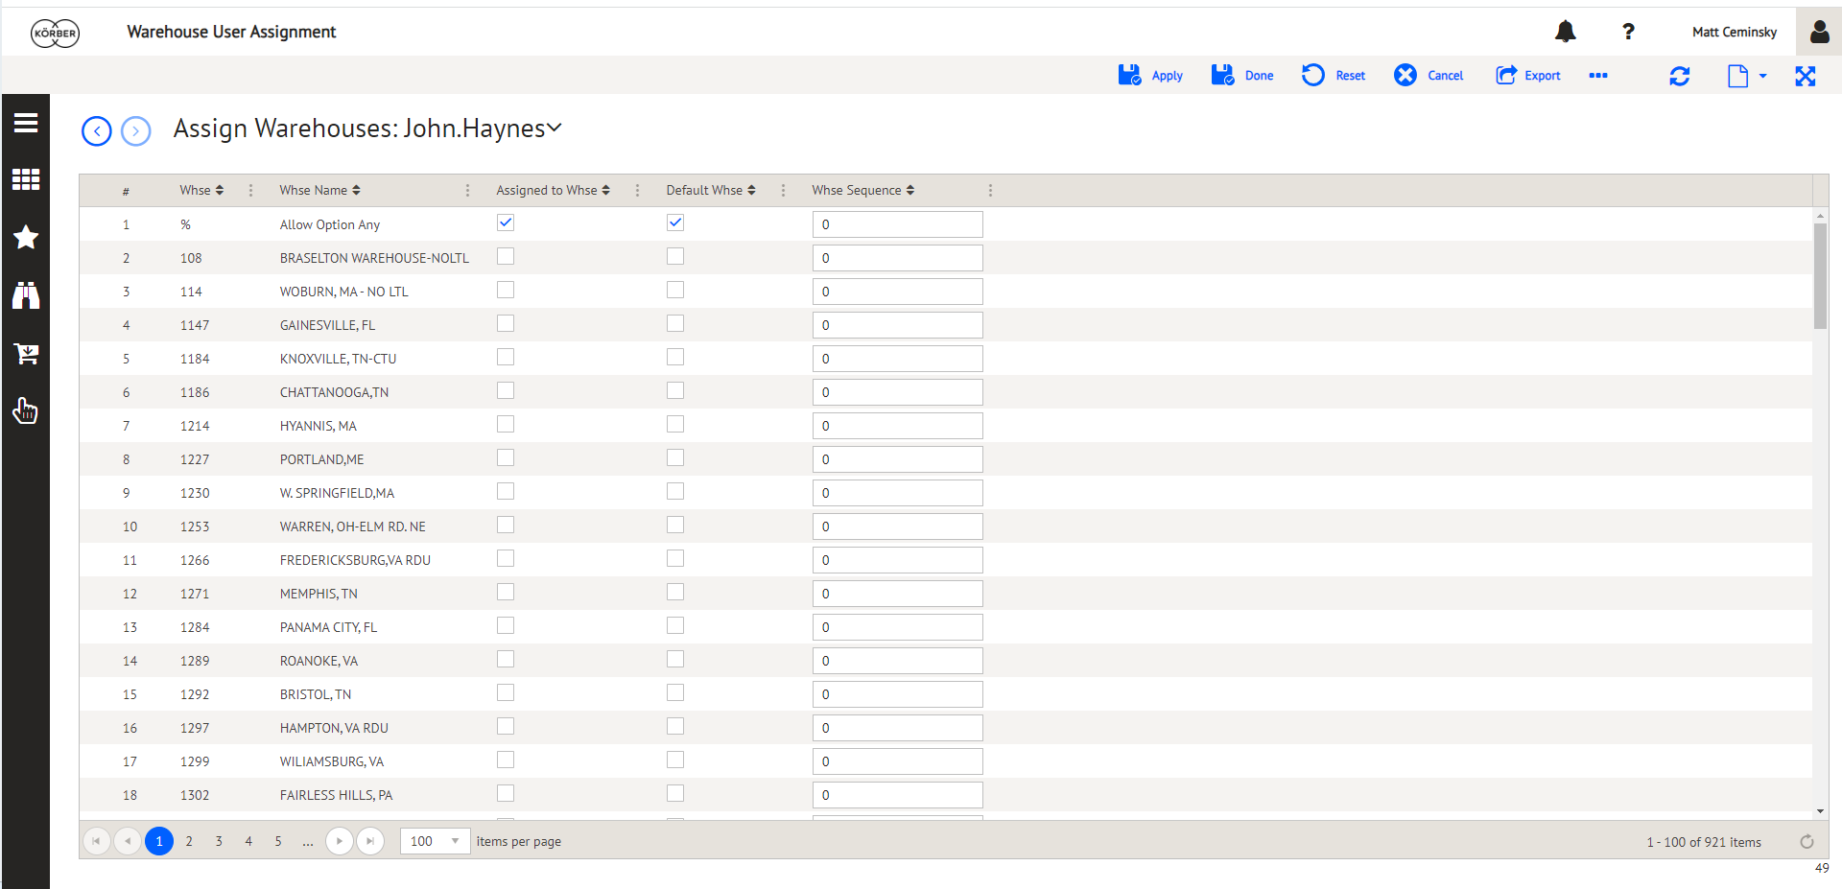  
   10. The assigned count should show the correct amount of warehouses that you assigned to the K1 user.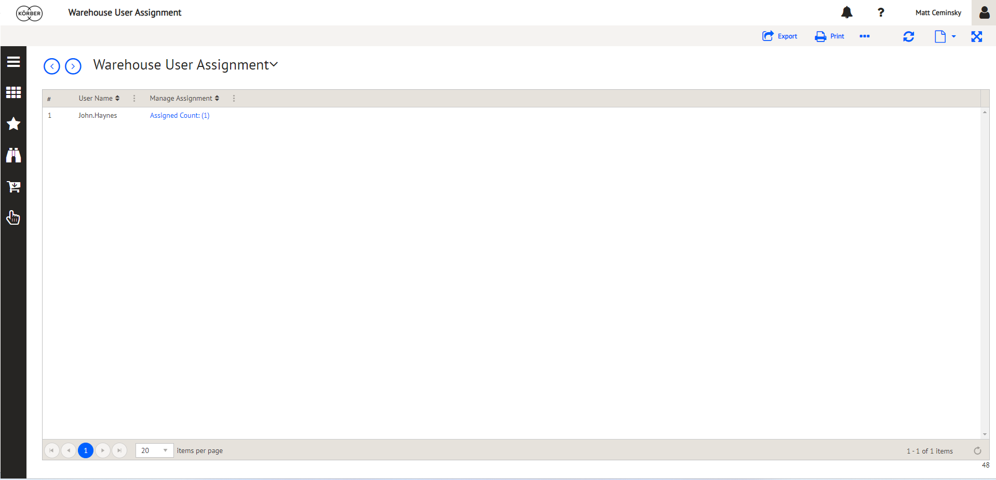  
   **Incident Resolution Note**:-  
     
   @Chaz Shields User has been created and assigned warehouse Columbus WHSE 227.

Username - Chaz Shields

Password – Safelite@123